**DSA0606-Data Handling and visualization for Clustering Algorithms**

**Harika A S (192224144)**

**1.R Pie Charts**

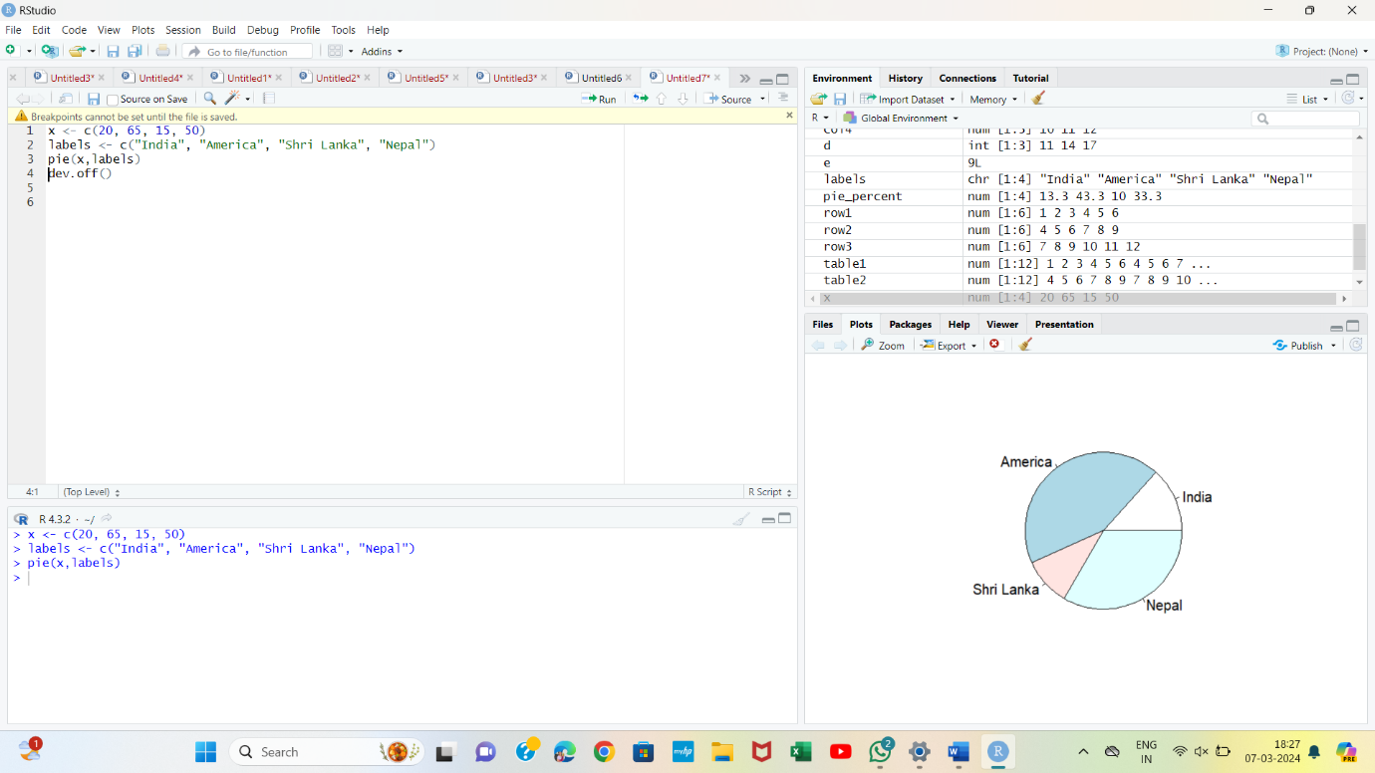

**2.Title and color**

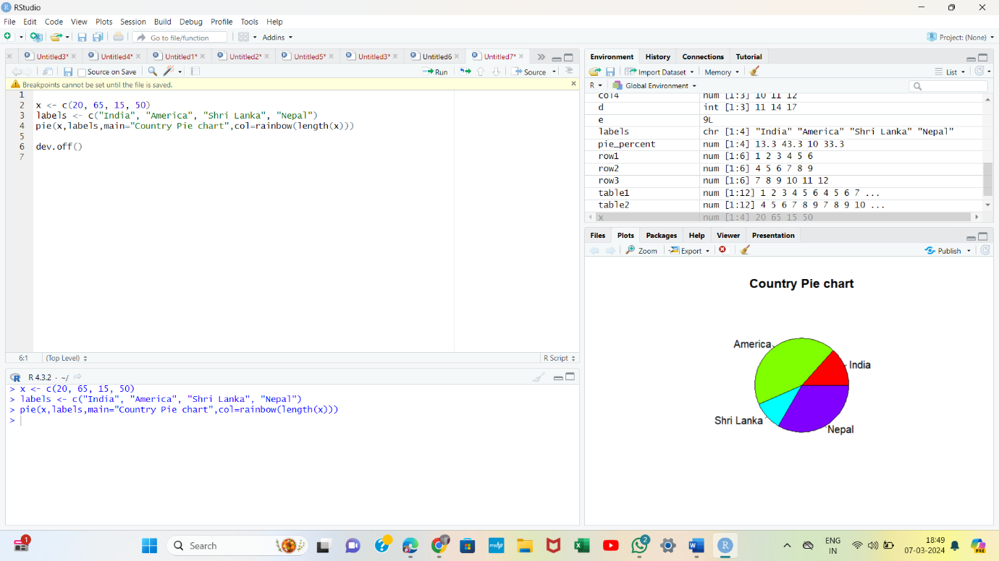

**3.Slice Percentage & Chart Legend**

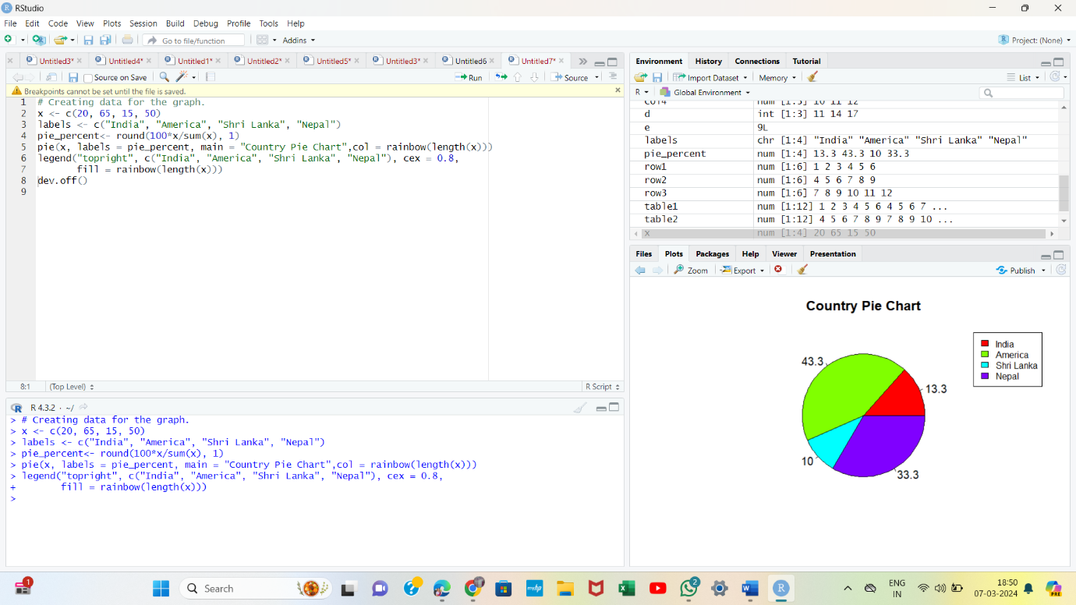

**4. 3 Dimensional Pie Chart**

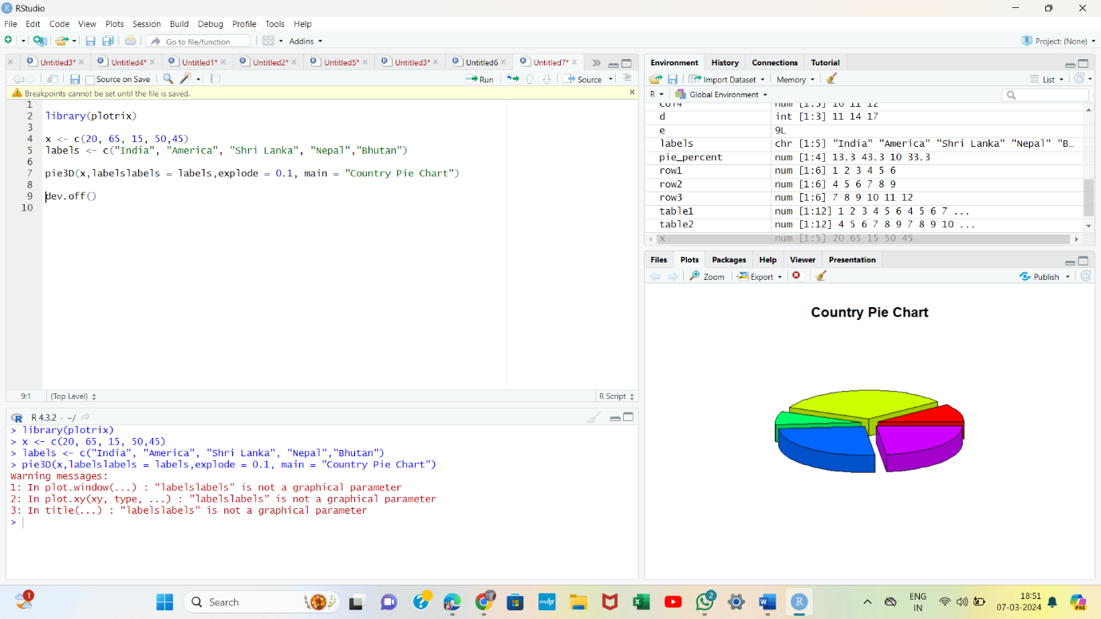

**5.**

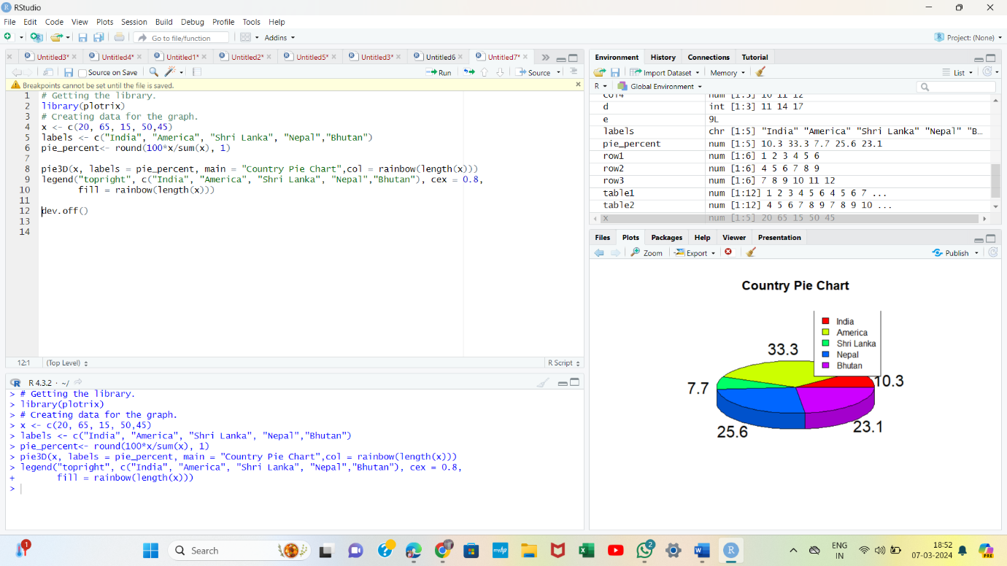

**6. R Bar Chart**

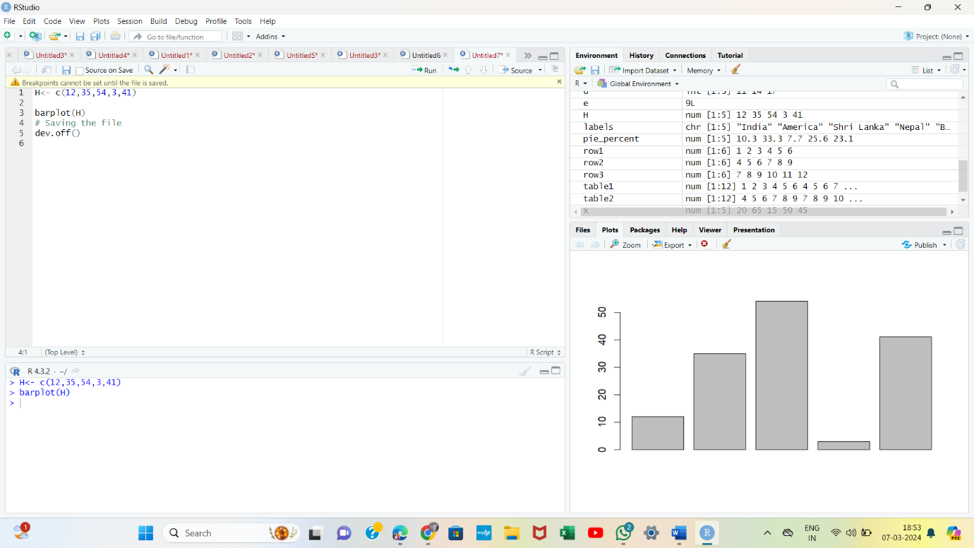

**7.Labels, Title & Colors**

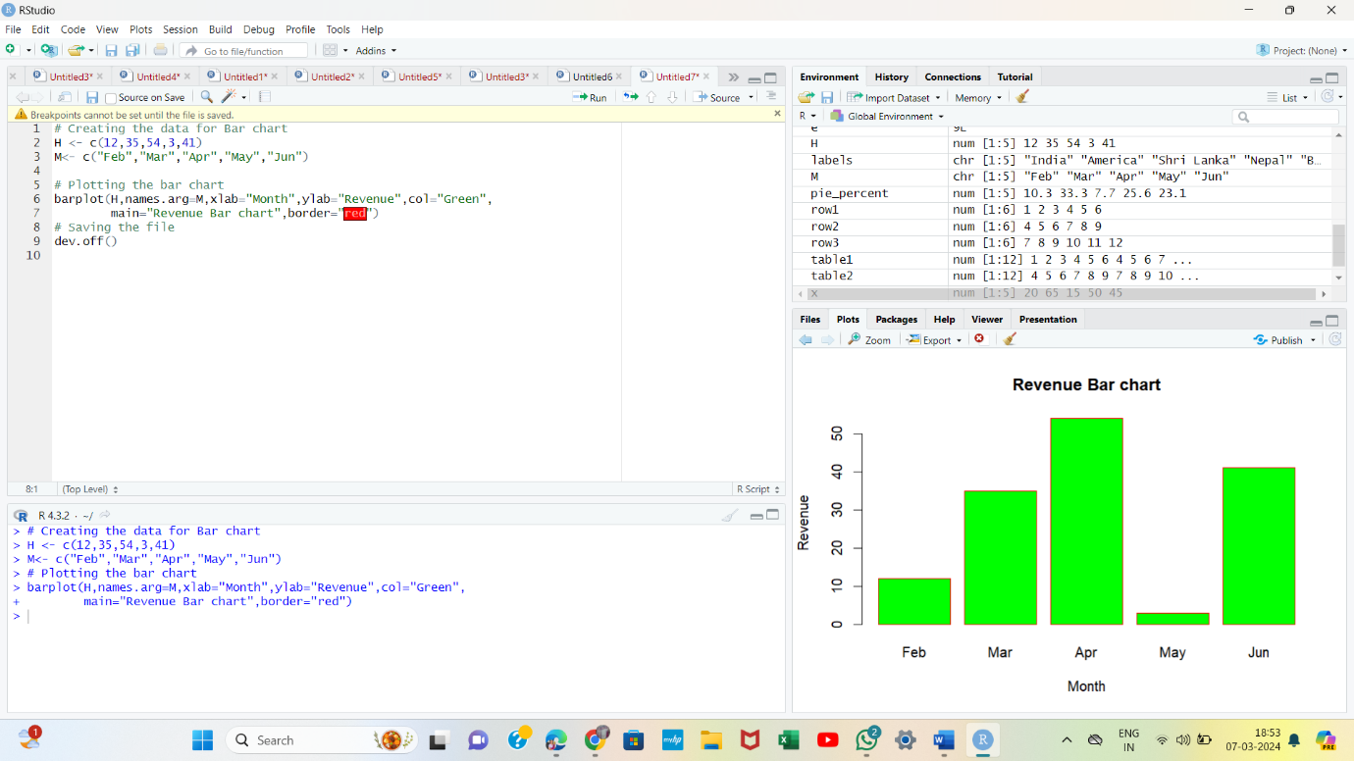

**8. Group Bar Chart & Stacked Bar Chart**

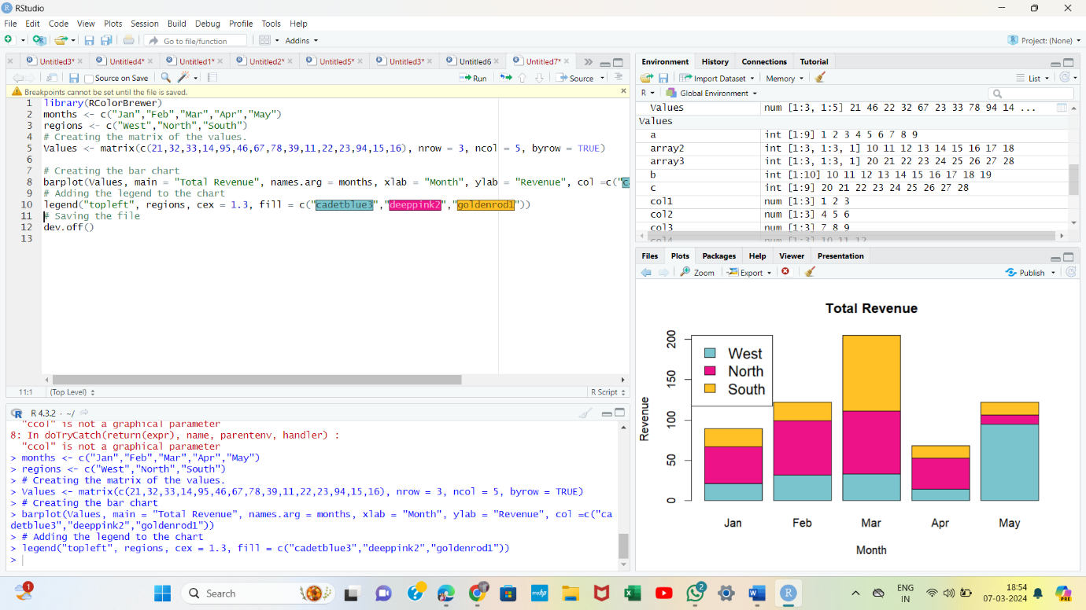

**9.R Boxplot**

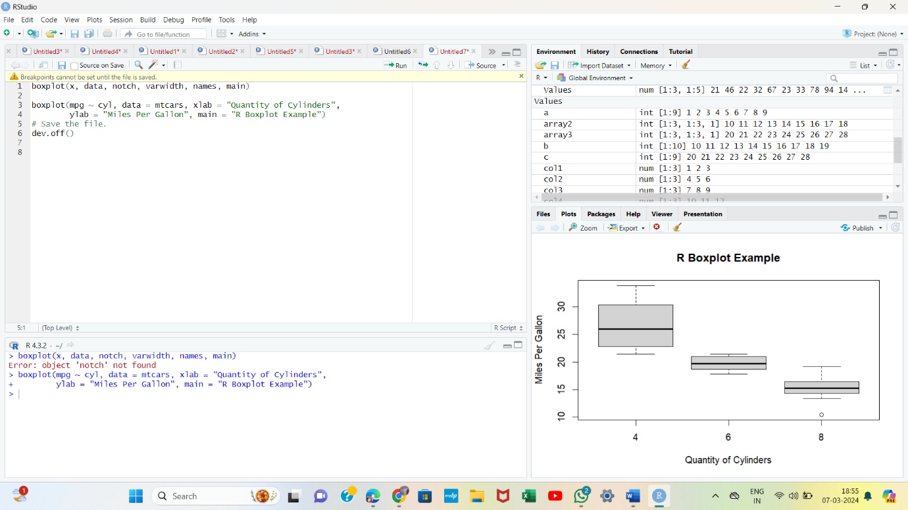

**10. Boxplot using notch**

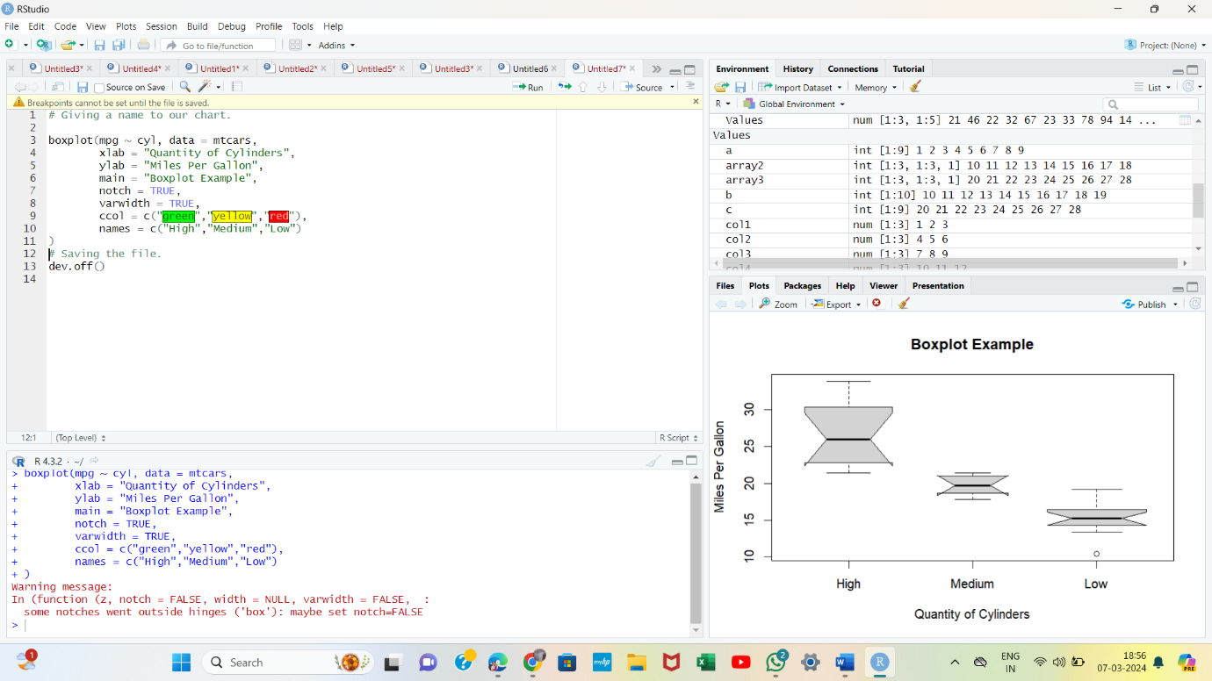

**11.Violin Plots**

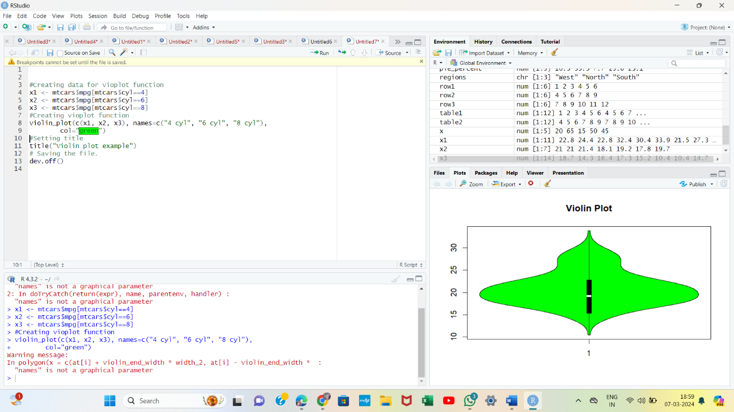

**12. R Histogram**

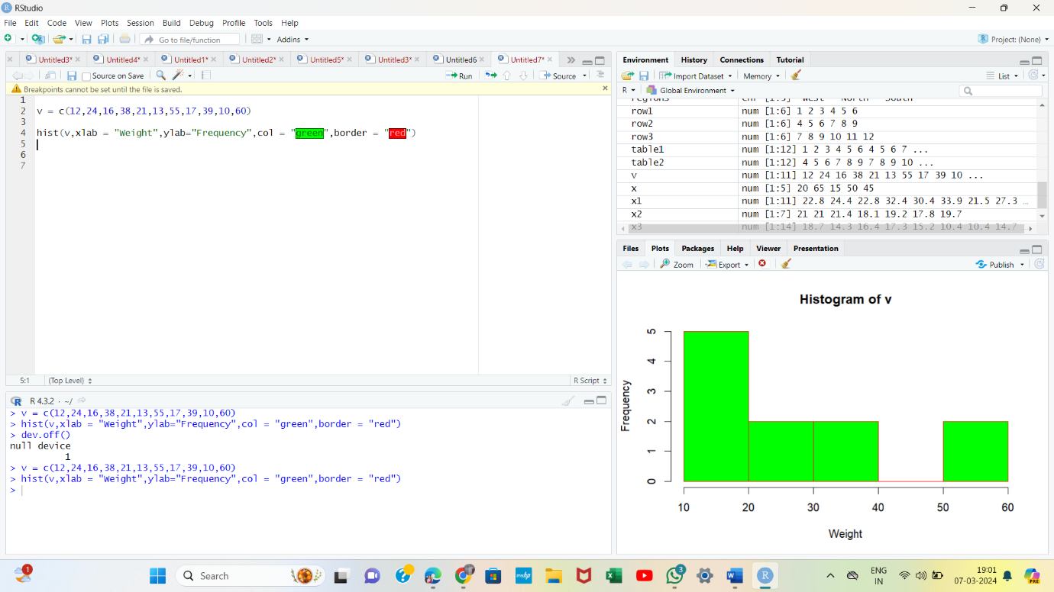

**13.Use of xlim & ylim parameter**

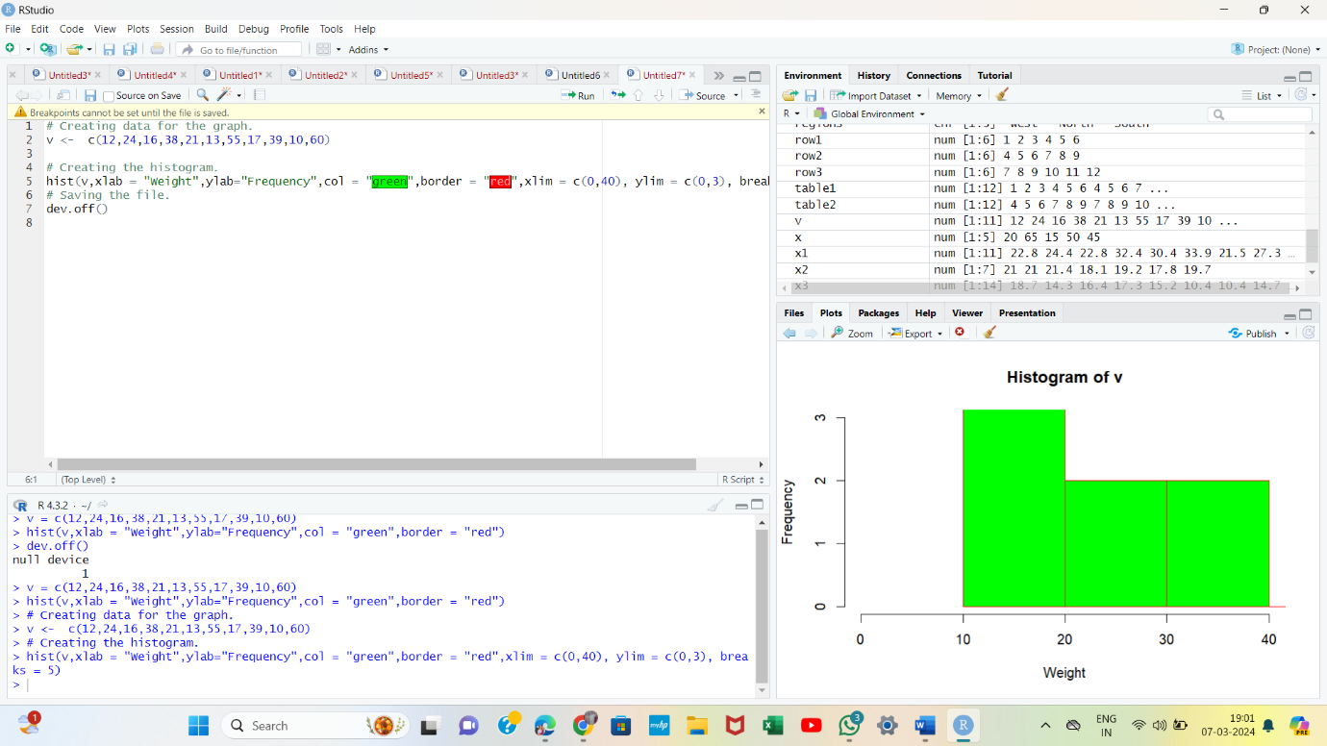

**14.R Line Graphs**

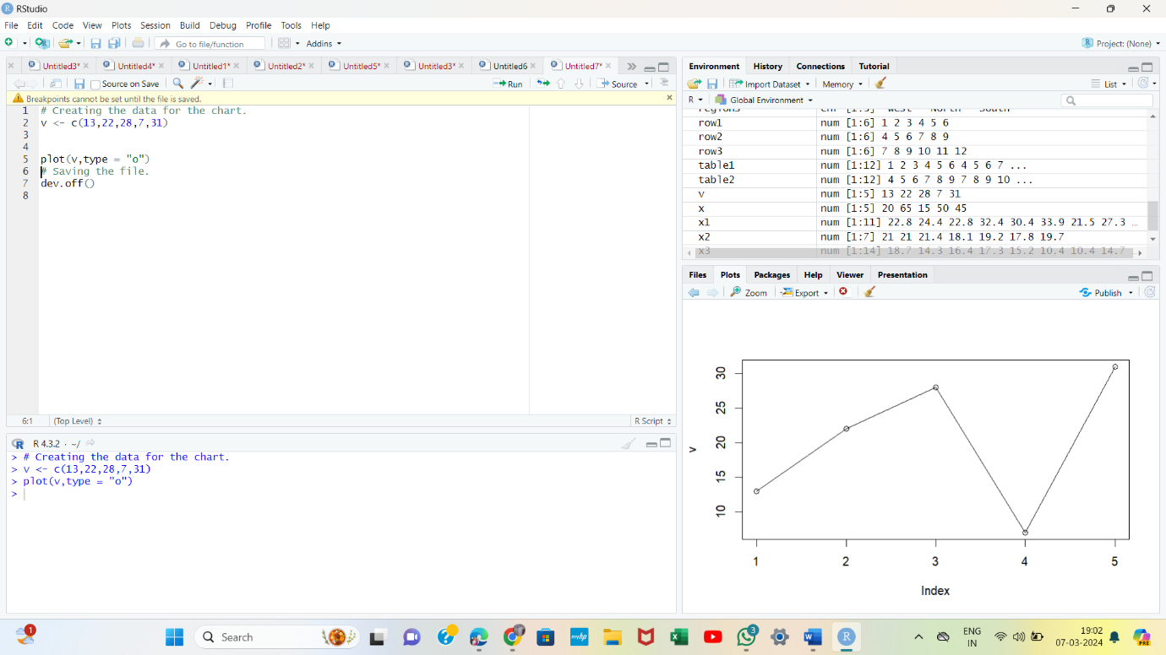

**15.Line Chart Title, Color, and Labels**

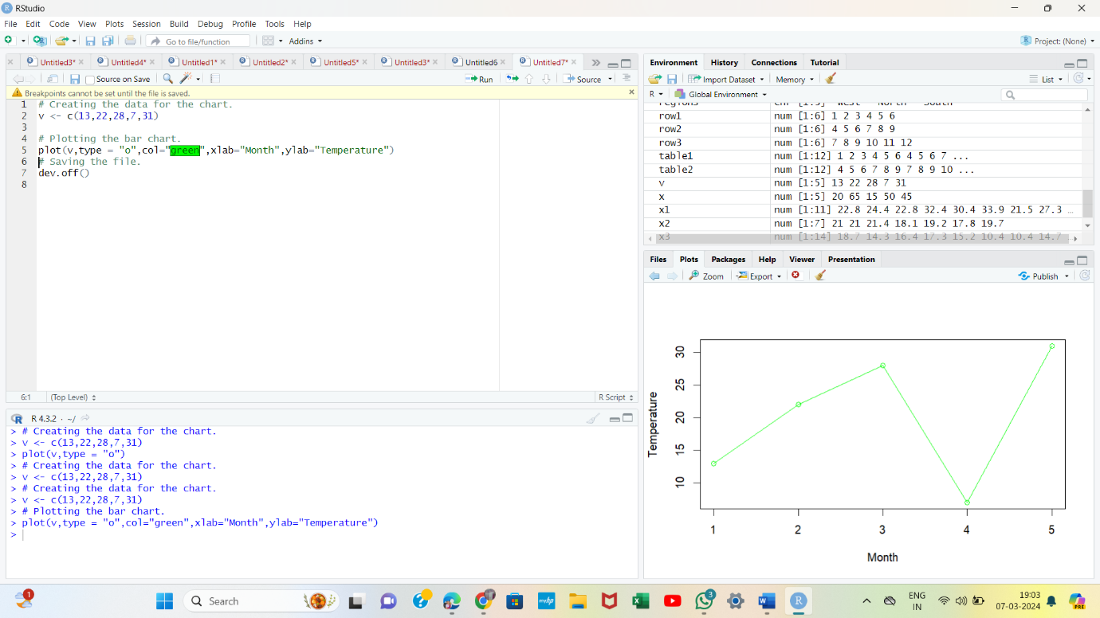

**16.Line Charts Containing Multiple Lines**

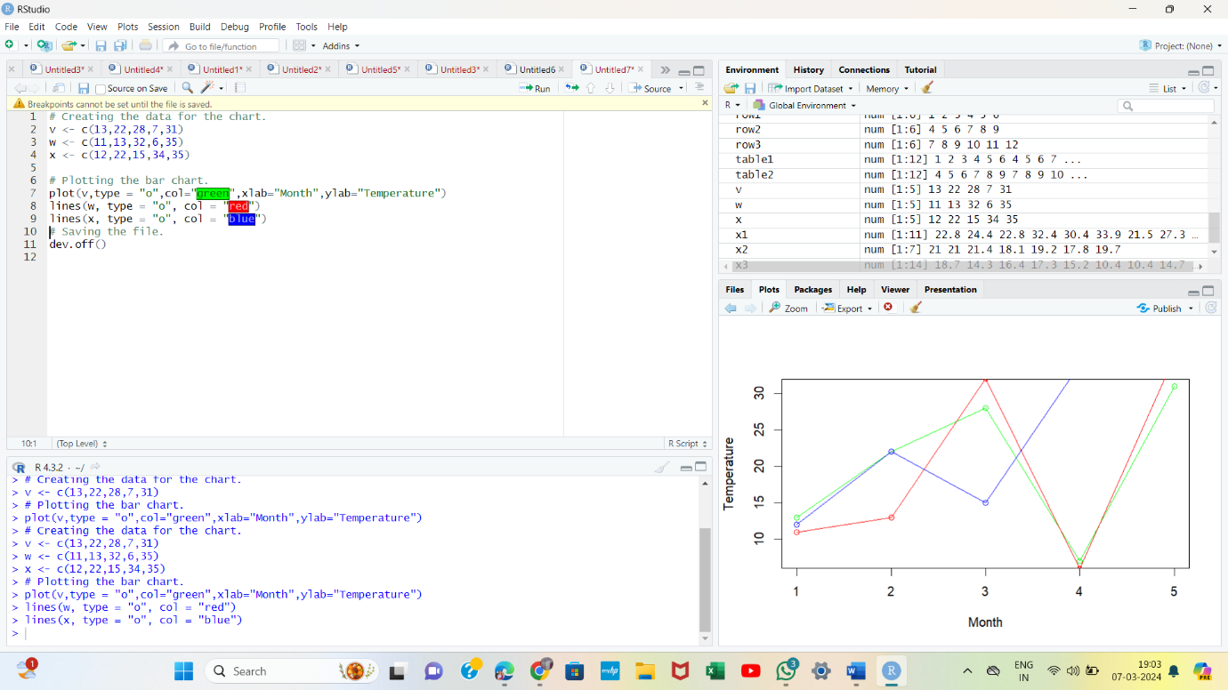

**17.Line Graph using ggplot2**

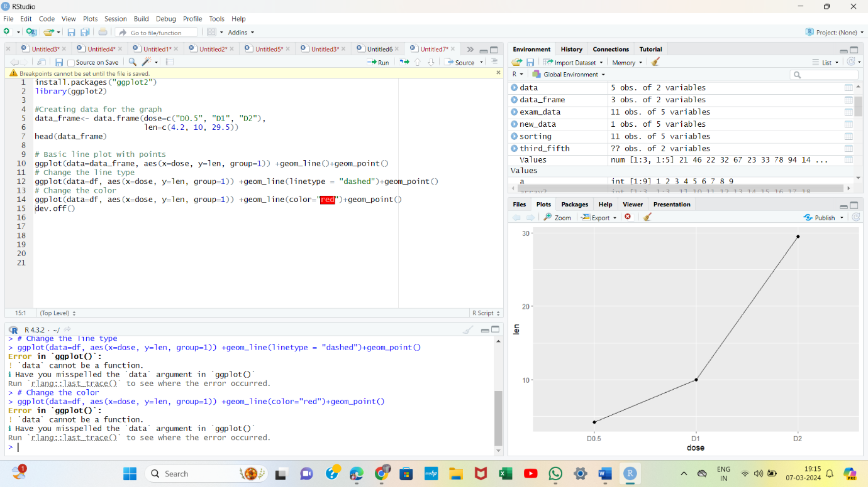

**18.R Scatterplots**

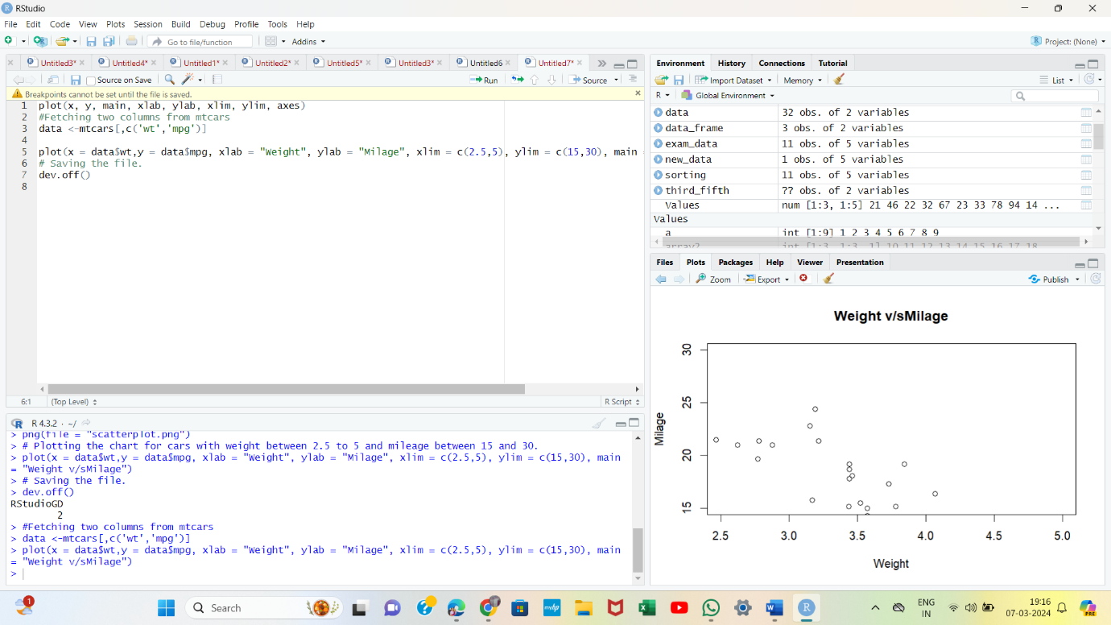

**19.Scatterplot using ggplot2**

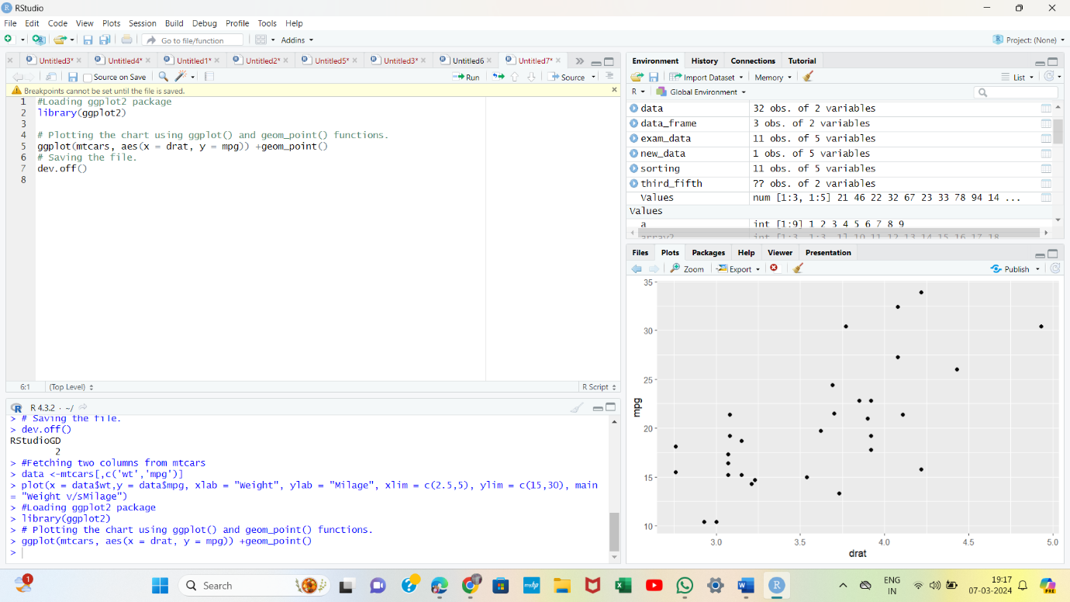

**20.Scatterplot with groups**

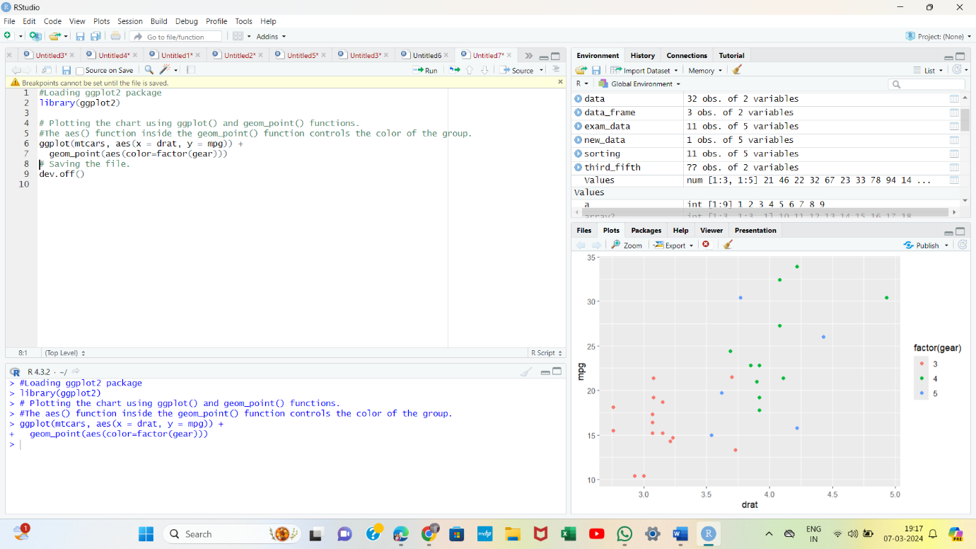

**21.Changes in axis**

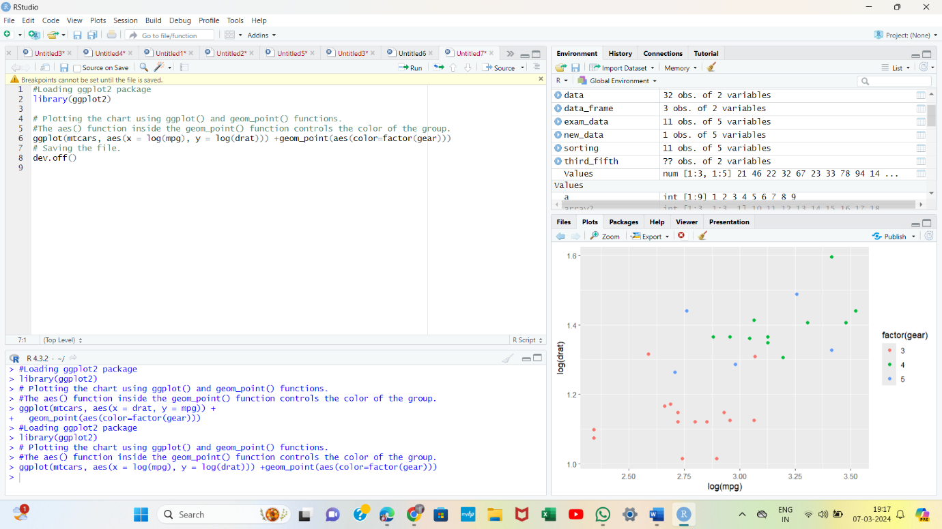

**22.Scatterplot with fitted values**

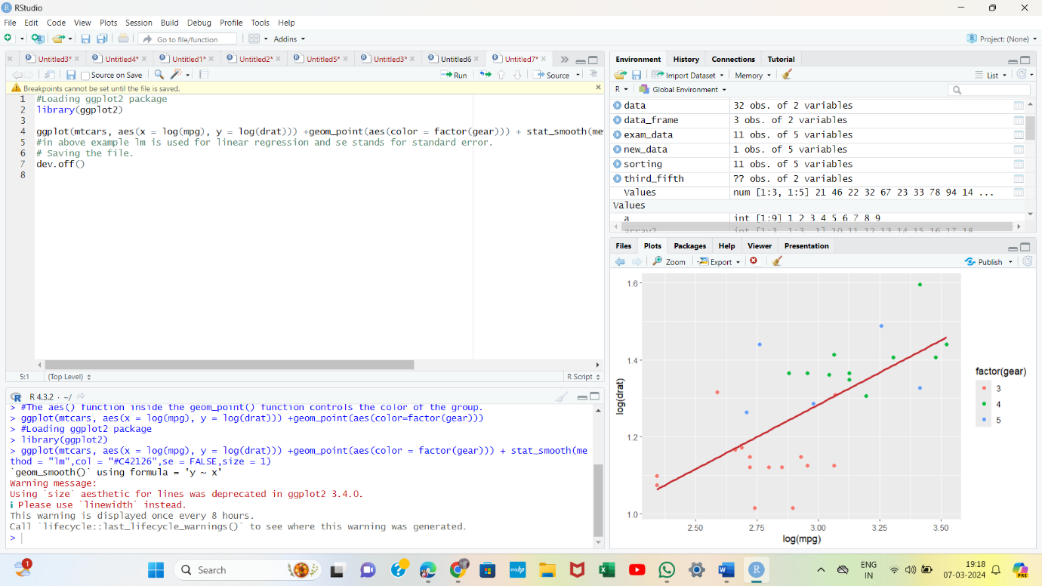

**23.Adding title**

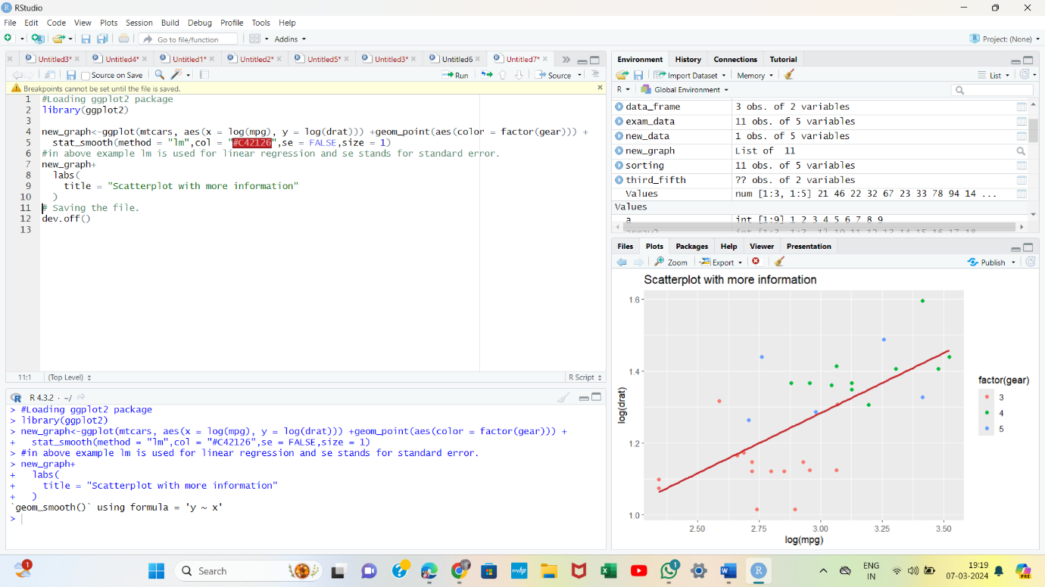

**24.Adding a sub-title**

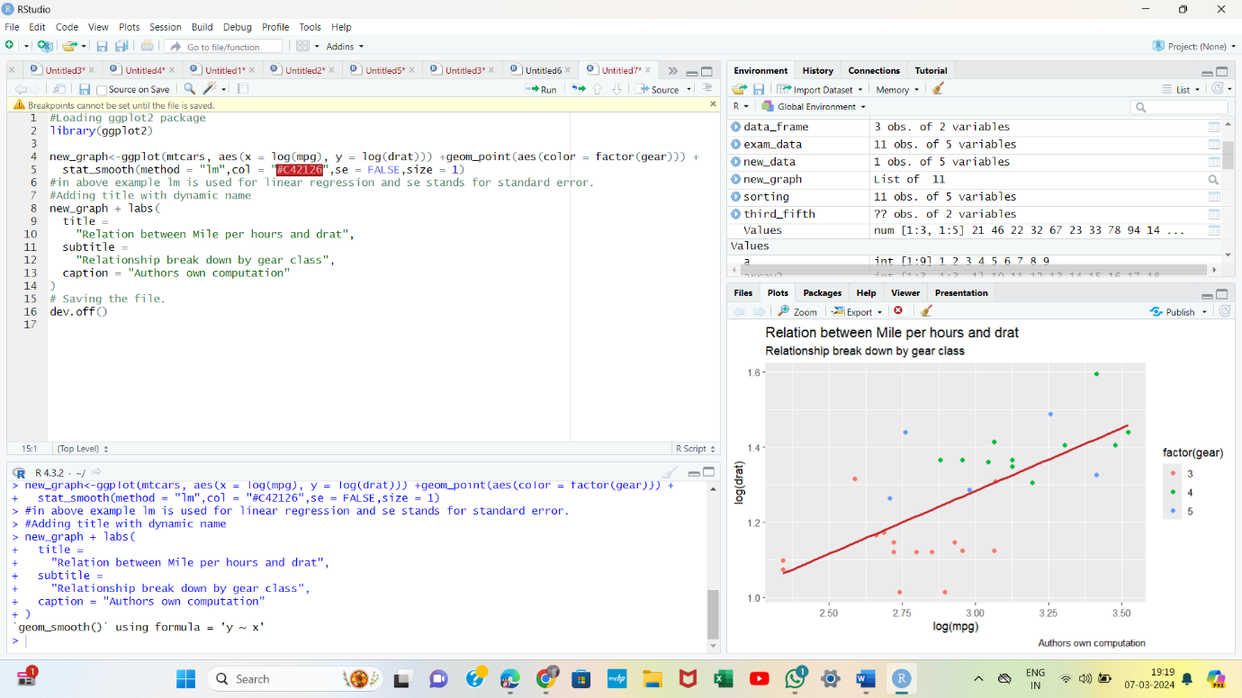

**25.Changing name of x-axis and y-axis**

